Lab: Username enumeration via different responses

Open the burpsuite and turn on the intercept in the proxy. Send the login page request to the intruder and select the sniper option to bruteforce one set of values. Add the set values of username in the payload under simple list in payload list type. Start the attack and you can get actual username with the length option. Similar try to find the actual password. Now login with the username and password that you found after the attack.

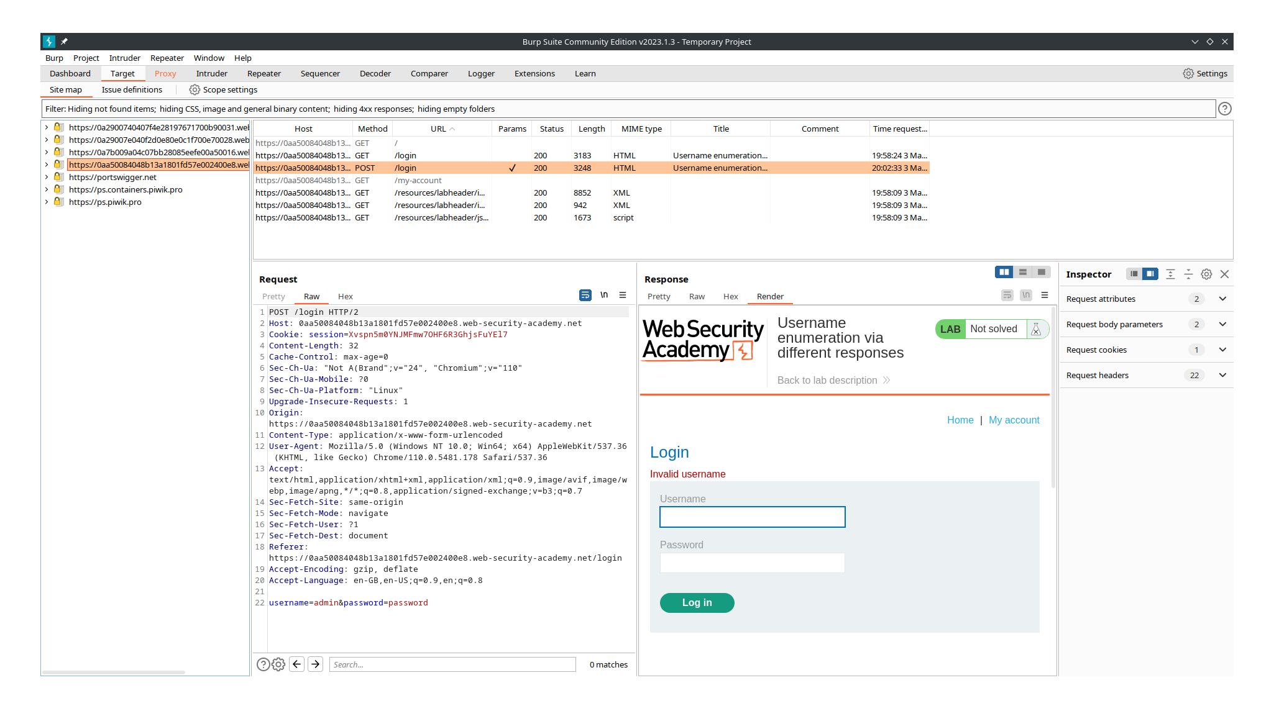

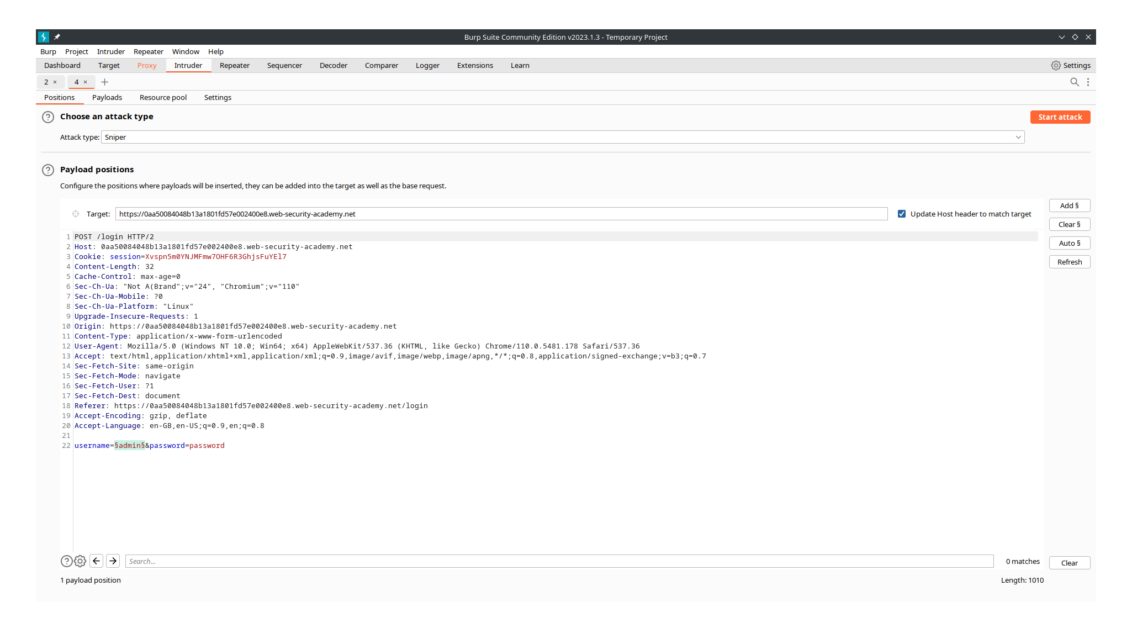
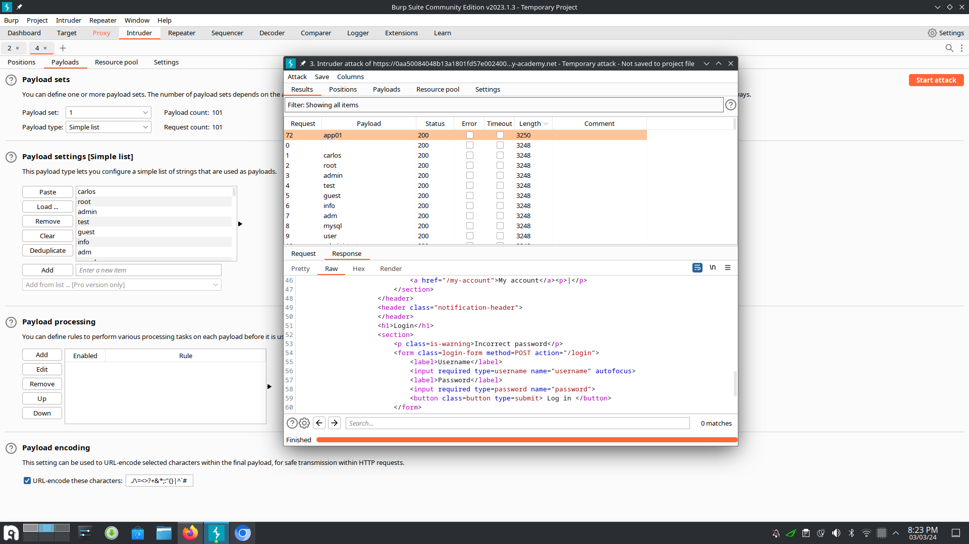

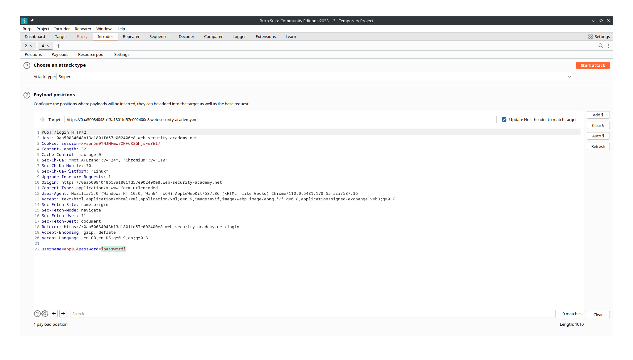
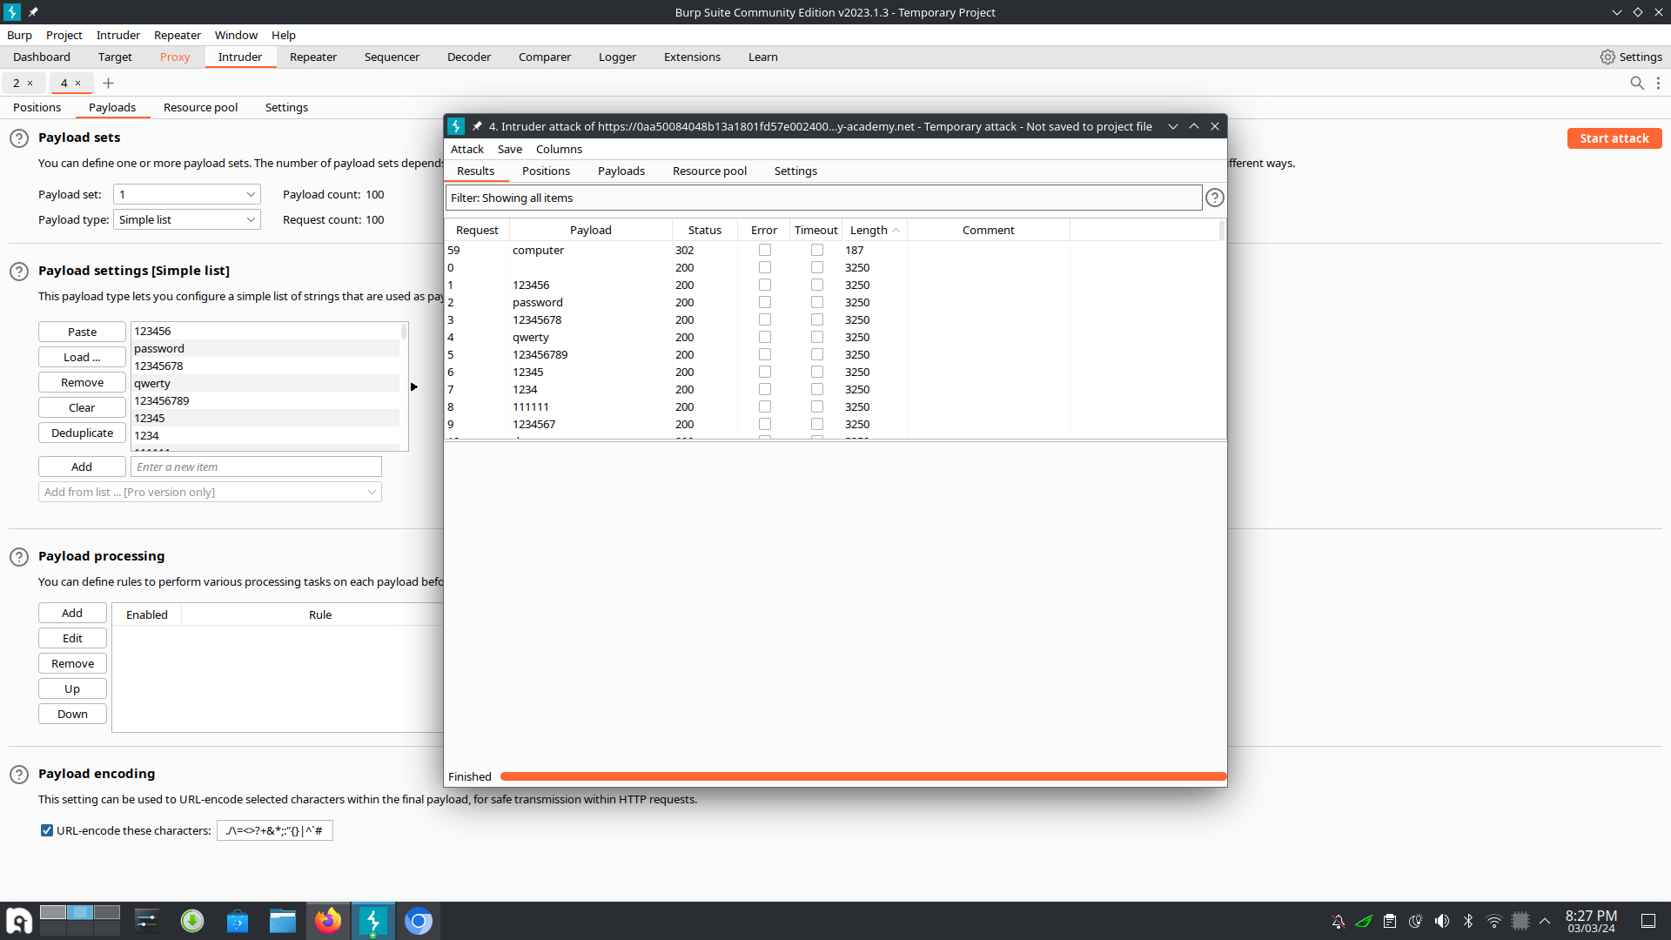

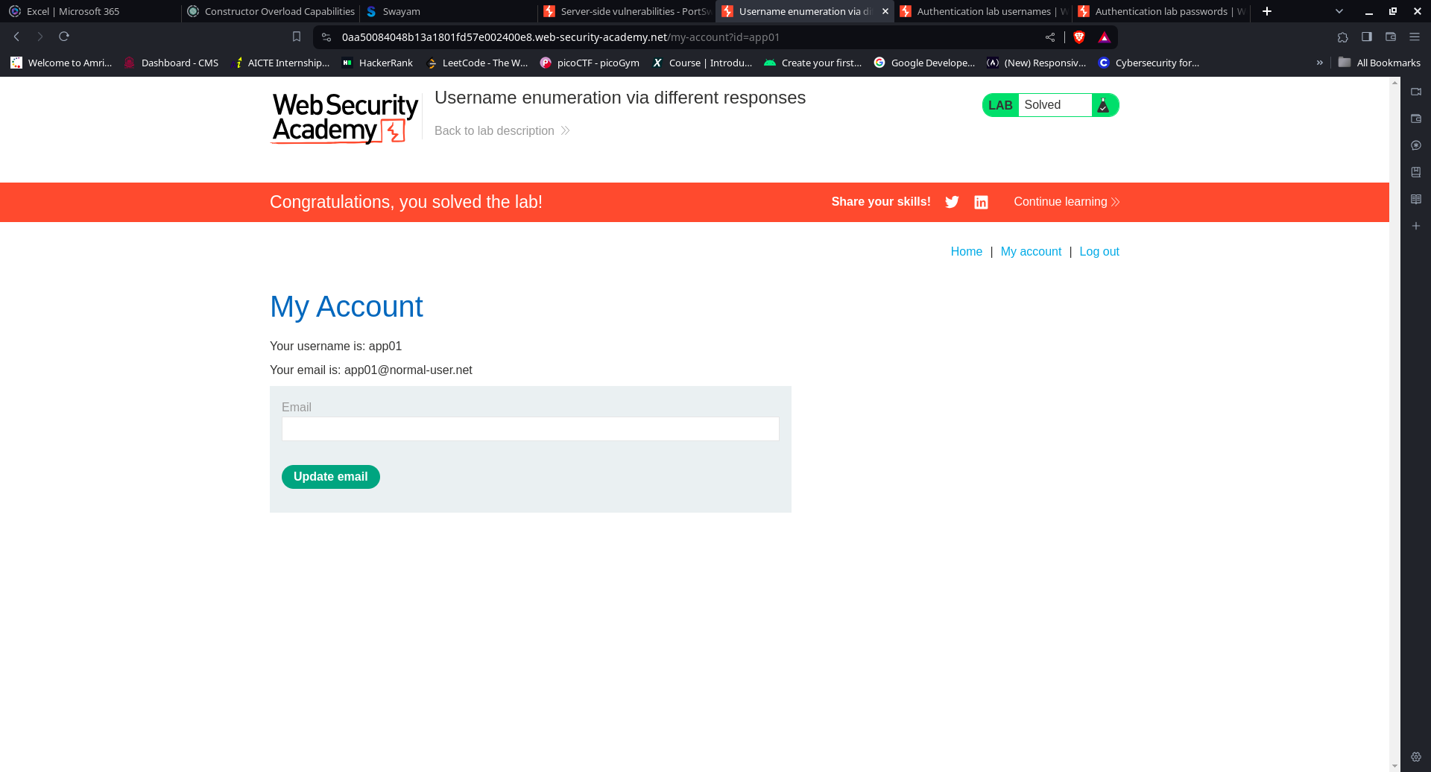

Lab: 2FA simple bypass

Open the burpsuite and turn on the intercept in the proxy. Login with given credentials and study those requests. Then login the credentials with carlos and forward the request to the repeater. Now change the login value to my-account in the request. Send the modified request and you will get into carlos’s account.

